Kafka Producer Step

Objective

A Kafka producer is an application that can act as a source of data in a Kafka cluster. A producer can publish messages to one or more Kafka topics.

**Record:** Producer sends messages to Kafka in the form of records. A record is a key-value pair. It contains the topic name and partition number to be sent. Kafka broker keeps records inside topic partitions. Records sequence is maintained at the partition level. You can define the logic on which basis partition will be determined.

**Topic:** Producer writes a record on a topic and the consumer listens to it. A topic can have many partitions but must have at least one.

**Partition:** A topic partition is a unit of parallelism in Kafka, i.e. two consumers cannot consume messages from the same partition at the same time. A consumer can consume from multiple partitions at the same time.

**Offset:** A record in a partition has an offset associated with it. Think of it like this: partition is like an array; offsets are like indexes.

UI

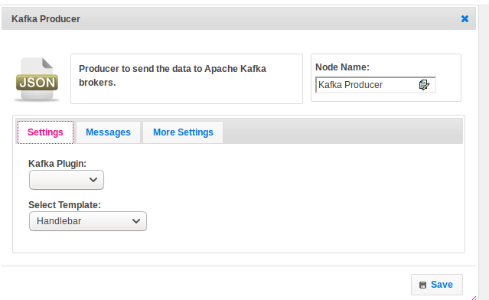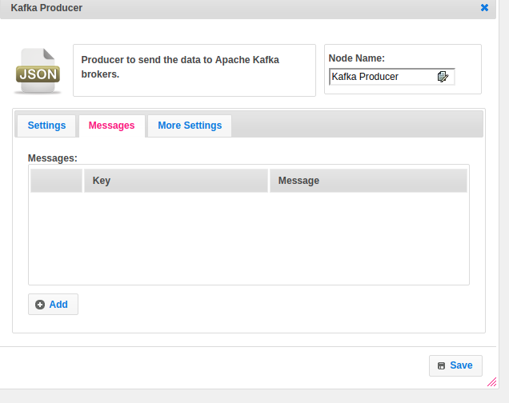

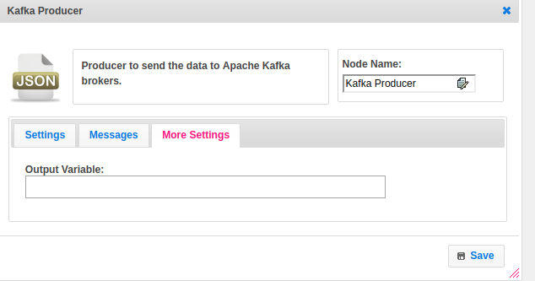

## Attributes

|  |  |
| --- | --- |
| **Attributes** | **Description** |
| **1. Kafka plugin** | Name of the plugin. The plugin contains all the configuration information. To get more details please find the below Dependent Plugin block. |
| **2. Select Template** | Select the template used to set the value type.  Value types are two types.  1.hb-HandleBars  2.ftl-Freemarker Template Language. |
| **3. Messages** | A message contains the information what you want to send. |
| **4. Output variable** | Used to store the response of the request. |

## 

## Executor Description

Publish a message to Kafka broker. Kafka producer pushes message in key, value pair in form of records. All the records are placed in each topic. Topic information we are given in plugin. It returns publish status. Add producer status to the respective list in response map.

## Plugin Dependencies:

|  |  |
| --- | --- |
| **Attributes** | **Description** |
| **1. Plugin Configuration name** | Name of the plugin |
| **2. Broker** | A Kafka broker receives messages from producers and stores them on disk keyed by unique offset.  A Kafka broker allows consumers to fetch messages by topic, partition and offset.  Kafka brokers can create a Kafka cluster by sharing information between each other directly or indirectly using Zookeeper. |
| **3. Username** | Provide the username |
| **4. Password** | Provide the password |
| **5. Auto Commit Interval(MS)** | By default every 5 seconds a Consumer is going to commit its Offset to Kafka or every time data is fetched from the specified Topic it will commit the latest Offset. |
| **6. Session Timeout** | Provide time for the session. |

## Resource:

To get more data about Kafka Producer please refer the following link

<https://dzone.com/articles/how-to-implement-kafka-producer>